Holly Jolly Christmas

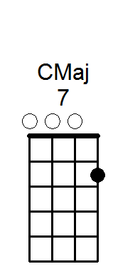
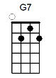
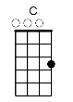
Have a [C] holly, [Cmaj7] jolly [C6] Christmas
It’s the best time of the [G7] year,
I don’t know if there’ll be snow,
but have a cup of [C] cheer [G7]

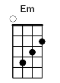
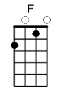
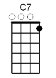
Have a [C] holly, [Cmaj7] jolly [C6] Christmas
And when you walk down the [G7] street
Say hello to friends you know
and everyone you [C] meet [C7]

[F] Hey ho the [Em] mistletoe
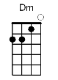
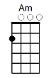
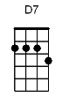
[F] hung where you can [C] see
[Dm] Somebody’s [Am] waiting there
[D7] kiss her once for [G7] me

Have a [C] holly, [Cmaj7] jolly [C6] Christmas
And in case you didn’t [G7] hear,
Oh, by golly have a [C] holly, jolly [D7] Christmas
[G7] this [C] year!

Repeat

